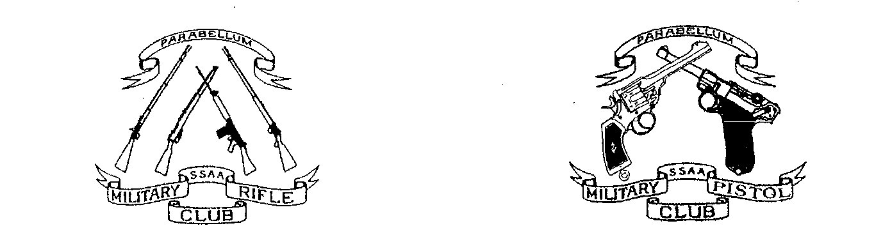

SSAA (ACT) MILITARY FIREARMS CLUB

The Military Firearms Club is one of the member clubs of SSAA (ACT) and conducts its matches in accordance with the Combined Services Discipline rules. We are a diverse club and our weekly matches cater for a range of interests. Subject to range availability our monthly program is:

Pistol 1st Sunday 1pm, Terry O’Brien Range
Class 1 pistol (military issue), Class 2 pistol (paramilitary issue) and Class 4 pistol (.22 cal) are used and matches are over distances from 50m to 7m, deliberate and rapid fire, in the standing, sitting/kneeling and prone positions.

Tactical Rifle 2nd Sunday 1pm, Jim McKinley Range
These rifles are generally as issued scoped military rifles (Class F1 and F2) or scoped tactical rifles in a military calibre (Class T). Matches are conducted over distances up to 500m. Occasionally the meeting will move next door to the Canberra Rifle Club to shoot over even longer distances.

Trainer Rifle 3rd Sunday 1pm, Crater Range
This is a growing area of our Club and these matches are designed for the .310 Cadet and the .22 Trainer class of rifle. More often than not we will have a side match for handguns.

Rifle 4th Sunday 1pm, Jim McKinley Range
Matches for Standard (as issued) military rifle and modified rifle. These matches involve distances of 100-300m. In collaboration with Canberra Rifle Club we have Remembrance Day and ANZAC matches for SMLE’s and other military rifles at the CRC Range.

Each year we compete in the CSD National Championships which we will be hosting in October this year. To spend three days with 100 passionate military devotees is an experience not to be missed.

To be a member of our Club you must be a member of SSAA and have, or be prepared to obtain, a range pass, $60 per year, for the Majura complex. Our current membership fee is $50 per year with a $15 nomination fee for the first year. Fees are for continuing members are due at the Annual General Meeting on the fourth Sunday in June. New members pay pro-rata until the AGM.

You do not have to own a military firearm to join the club as there are club pistols and rifles available. If you do not have a firearms licence we can assist you in obtaining one and we have firearms instructors available at both pistol and rifle matches.

SHOOTING IS A SAFE AND ENJOYABLE SPORT. WE TAKE SAFETY SERIOUSLY AND SO MUST YOU. IT IS AN ABSOLUTE RESPONSIBILITY OF ALL MEMBERS TO HANDLE FIREARMS SAFELY AT ALL TIMES.

Rules of Combined Services Discipline Firearm and ammunition requirements.

David Thompson
Discipline Coordinator
Military Firearms Club
What must I do if I want to participate with the Military Firearms Club?
These steps are for the prospective member who is new to shooting and resides in the ACT. If you are already an active SSAA member or shooter you can disregard some of this.
Rifle (Class A/B) member
- Join SSAA. The preferred option is to use the online application or alternatively you could pay $83 cash at the SSAA Range Office. Both of these options provide you with a receipt which can be used in lieu of your SSAA membership card which will probably take two months to arrive.
- Book in for a firearms safety course. Contact -0414 456 430 or book via email Secretary.ssaa.act@gmail.com. Sessions are held at 6pm on the fourth Thursday of each month at the SSAA clubhouse - cost $50 adults, juniors free.
- Join Military Firearms Club by paying your pro-rata membership dues and nomination fee to SSAA Military Rifle Social Club, BSB 732-636, account # 000523871, putting your name under details. Membership dues are $5 per whole or partial month up until the end of June to a maximum of $50 which is the whole year rate. The nomination fee is $15 for a new member.
- Fill in the adult firearms licence application for categories A and B and get this endorsed by the Discipline Coordinator. Take this application together with 100 points of ID, an ACT shopfront receipt for $120 and your firearms safety certificate and head off to the Firearms Registry at 86 Vicars Street Mitchell. The Firearms Registry is open from 8am to 1pm and 2pm to 4pm Monday to Friday with the exception of the fourth Friday of each month when it is closed.
- Get a pro-rata SSAA range pass for $5 per complete or partial month up to the end of June - I can issue this at the range.
Additional requirements for a pistol (Class H licence) member
- Make application for a National Police Check.
- Provide the Military Firearms Club with two character references from people who have known you for at least five years and are not related to you. If you are known to Club members we will not require that you provide the references prior to you participating in club matches but we will require to sight the references before we approve your application for an H class licence.
- Before you start handling pistols you must pass a written and/or oral examination in safe handling techniques for handgun.
- You then commence your minimum six month and six match probation period. During this period you will have to hire pistols and purchase ammunition from the Club. At all times during the probation period you will be under the guidance of an MFC instructor. Initially you will be using a .22LR pistol then you will progress to a self loading pistol and revolver.
- After the probation period has finished and you have met all requirements, the Club will endorse your application for an H class licence. You then take the MFC approved H class licence application, together with the National Police Check certificate, 100 points of ID, character references and shopfront receipt to the Firearms Registry. If this is a new licence the fee will be $120 for 5 years but if you are upgrading an existing licence the fee will be $40.
- Please be aware that club endorsement is not automatic for completing the probation requirements. If the MFC Committee is not satisfied that you are genuinely interested in participating in club activities we will either extend your probation period or advise you that we will not support your application for an H class licence.
- In your first six months as an H class licence holder you may apply to acquire a pistol and after you have completed six months as an H class licence holder you may apply to acquire a second pistol which is a different type to the first. The two types are rim fire and centre fire. All pistol acquisitions must be endorsed by the Club.
- As an H class licence holder you must attend a minimum number of times (6) in any year or at least four times with rim fire and four times with centre fire if you own both classes of pistol.

If you are a NSW resident club endorsement comes via SSAA ACT Inc on the recommendation of MFC. Most of the licensing procedures are similar though there are additional steps in pistol licensing.

For enquiries please contact me on 0468 513 265 or mfc.ssaa.act@iinet.net.au. I usually put out at least one email per week to members detailing coming events.

